Test Project   
Competitor Information Document

Autonomous Mobile Robotics

Contents

1. 1. Introduction 4
2. 2. Description of project and tasks 4
   1. 2.1 Main Test Project 4
3. 3. Instructions to the Competitor 5
   1. 3.1 Competition Requirement 5
   2. 3.2 Activities to be completed before the Competition 5
4. 4. Equipment, machinery, installations, and materials required 6
   1. 4.1 Equipment provided by Competition Organizer 6
      1. 4.1.1 VMX 6
      2. 4.2.2 Competitor Computer 6
   2. 4.2 Equipment and material not permitted 7
   3. 4.3 Items to be provided by the teams 7
5. 5. Main Test Project 8
   1. 5.1 Module A - Work Organization, Management and Communication 8
      1. 5.1.1 Completion Time: 8
      2. 5.1.2 Assessment Criteria: 9
      3. 5.1.3 Module Task: 9
   2. 5.2 Module B – Design 9
      1. 5.2.1 Completion Time: 9
      2. 5.2.2 Assessment Criteria: 9
      3. 5.2.3 Module Task: 10
   3. 5.3 Module C – Prototyping 10
      1. 5.3.1 Completion Time: 10
      2. 5.3.2 Assessment Criteria: 10
      3. 5.3.3 Module Task: 10
   4. 5.4 Module D – Navigation and Localization 10
      1. 5.4.1 Completion Time: 10
      2. 5.4.2 Assessment Criteria: 11
      3. 5.4.3 Module Task: 11
      4. 5.4.4 Specific Equipment: 11
   5. 5.5 Module E - Vision 11
      1. 5.5.1 Evaluation Time: 11
      2. 5.5.2 Assessment Criteria: 11
      3. 5.5.3 Module Task: 11
      4. 5.5.4 Equipment: 11
   6. 5.6 Module F – Robot Environment Interaction 12
      1. 5.6.1 Evaluation Time: 12
      2. 5.6.2 Assessment Criteria: 12
      3. 5.6.3 Module Task: 12
      4. 5.6.4 Equipment: 12
   7. 5.7 Module G – Testing and Fault Finding 12
      1. 5.7.1 Completion Time: 12
      2. 5.7.2 Assessment Criteria: 12
      3. 5.7.3 Module Task: 12
      4. 5.7.4 Equipment: 13
   8. 5.8 Module H – Performance and Commissioning 13
      1. 5.8.1 Completion Time: 13
      2. 5.8.2 Assessment Criteria: 13
      3. 5.8.3 Module Task: 13
      4. 5.8.4 Equipment: 13
   9. 5.9 Mock Schedule 14
   10. 5.10 Test Project Summary 14
6. Appendix A - Work Organization, Management and Communication 15
7. Appendix B - Design 15
8. Appendix C - Prototyping 16
   1. C.1 – Example List of Parts 16
   2. C.2 – Example Task for Module C 17
9. Appendix D - Navigation and Localization 18
   1. D.1 – List of Sample Robots that might be used for Module D 18
   2. D.2 – Example Task for Module D 18
   3. D.3 – Example Court for Module D 19
10. Appendix E –Vision 20
    1. E.1 – Example set fruits or Module E 20
    2. E.2 - Example Task for Module E 21
11. Appendix F - Robot Environment Interaction 21
    1. F.1 – Example Task for Module F 21
12. Appendix G - Testing and Fault Finding 22
    1. G.1 – Example Task for Module G 22
13. Appendix H - Performance Review and Commissioning 22
    1. H.1 – Task Procedures 22
       1. H.2.1 Sample Sequence for Runs 1 and 2 23
       2. H.2.2 Sample Sequence for Runs 3 23
       3. H.2.3 – Example Order Run 1 or 2 24
       4. H.2.4 – Example Order Run 3 24
    2. H.3 –Module Items 26
       1. H.3.1 – Competitor Designed Basket 26
       2. H.3.2 – Seed Pod Dispenser 27
       3. H.3.3 – Sample Seed Pods 28
       4. H.3.4 – Sample Object: Grapes 29

# 1. Introduction

The primary focus of the WorldSkills 2024 Autonomous Mobile Robotics CID is to outline the requirements for Competitors to assemble/prepare/manage/repair robots to interpret multiple environments and tasks in various environments that will be introduced onsite at the competition. It is expected that robots will take the environmental information they have gathered and use this information to manage both their overall mobility and target object handling experiences.

The agriculture sector is experiencing a surge in automation and robotics, leading to an increased demand for mobile robotic technicians and engineers who can develop and maintain robotics systems in this industry. As part of the WorldSkills 2024 Lyon competition, participants are tasked with designing, constructing, and operating a Mobile Robot that meets all performance requirements. To accomplish this, Competitors must carefully analyze the information presented in this document to identify the primary set of performance requirements for the Mobile Robot. The Mobile Robotics skill at WorldSkills 2024 in Lyon will introduce various modules that target the specific skills of a Mobile Robotics Technician or Engineer.

The Robot will be able to function autonomously in multiple environments. The appendices present sample environments and guidelines that can be used for preparation purposes. For example, the Robot can manipulate objects of varying size and weight, from various locations on a course and deposit them in specified positions.

In addition, Competitors will be expected to manage their robot’s mobility in an unknown environment. This experience will require the robots to demonstrate their capability to complete a navigation and localization task with a supplied sample robot.

# 2. Description of project and tasks

## 2.1 Main Test Project

Teams of two Competitors are required to design and build a mobile robot that will efficiently operate in custom environments that represent real-world scenarios or tasks.

The main Test Project is broken down into various modules in accordance with the WorldSkills Occupational Standards (WSOS). Competitors are expected to identify the Primary Set of Mobile Robot Performance Requirements through analysis of the information provided in this document:

Robots are required to move mostly autonomously throughout any performance evaluation environment,

Robots are required to Take control of the various target objects and move them to within in the performance environment.

**Note:** The Primary Task that Competitors must complete on C-2 is to prepare the team’s laptops and complete the re-assembly of their robot in time to make it available to complete tasks as required on C1.

# 3. Instructions to the Competitor

## 3.1 Competition Requirement

Each Team will receive the following at the event:

* One WorldSkills 2024 Lyon Mobile Robotics Component Collection from Studica. Competitors are expected to develop their mobile robots using the components provided in the collection.
* In addition to the supplied collection, Competitors can ‘purchase’ additional Studica Robotics parts (only) to a value of up to 400 Studica Points. Individual ‘costs’ and availability will be announced four months prior to the competition (C-4 months) on the official WorldSkills Discussion Forum. Teams must select those parts by placing a quote on the Studica website within one month of the announcement. The final list will be published three months prior to the Competition (C-3 months) to ensure that they are available on site. That will be the last change allowed to the list, and any change request after that will not be authorized.

The Studica Kiosk can be found on the Studica website: <https://www.studica.co/lyon-sales-kiosk>. The page includes instructions on placing a quote. The quote will also prove to the Experts what extra components are given to Competitors.

The equipment purchased using Studica Points is mostly focused on the team’s use in Module H, but the parts can be used during in any module where the Competitors can use their robots.

Competitors will be allowed 3D printed parts and parts made from sheet stock as per the requirements specified in this document.

An assembled robot must begin any test run with the following size restrictions:

The Competitor robot will be measured using a measuring device to ensure that its unique starting (pre-match set-up) configuration fits within a 600 mm x 600 mm x 600 mm requirement.

Surprise Test Project Modules or Tasks – the Surprise Test Project Modules or Tasks will be released to Competitors during meetings, and no notes may be taken at this time.

## 3.2 Activities to be completed before the Competition

Design, Prototyping, and Testing of the Competitor Robot and manufacture of all permissible Competitor designed components needed by the team to assemble their robot for the Test Project.

Competitors could also prepare custom wiring harnesses for the competition robot for the main Test Project.

Preparation of all items for Module B.

*Note: Studica items/components are not to be modified in any way prior to the Competition. Subject to penalty with withdrawal of item or additional time on team or increase in item cost.*

# 4. Equipment, machinery, installations, and materials required

## 4.1 Equipment provided by Competition Organizer

A WorldSkills 2024 Lyon Mobile Robotics Component Collection, sample test elements, and any purchased (kiosk items) Autonomous Mobile Robotics Competition components will be provided on C-2 to all Competitors (one kit/set per team).

All Competitors will receive a laptop on C-2 with the core programming tools installed (two laptops per team).

All equipment, tooling, and materials are in the Infrastructure List – see WorldSkills Discussion Forum and Technical Description.

* All materials for any surprise Test Project as listed in the Technical Description;
* Testing equipment for fault finding module;
* Objects required for manipulation during the performance tasks and testing;
* Test court for the performance evaluation tasks;
* Test walls and objects for the navigation and localization tasks and , ranging from 300 mm to 600 mm;
* Sample Robot with instructions for the navigation and localization task;
* Sample platform with faults and instructions for the fault-finding module;
* Parts and tools required to complete the Prototyping module.

### 4.1.1 VMX

For all modules except for module D (Navigation and Localization), Competitors may use any software that runs on the VMX.

For module D, the provided VMX will run the WPILib C++ and Java default configuration.

### 4.2.2 Competitor Computer

For all modules except for Module D, Competitors may use any software, understanding that no support will be given.

The computer will contain all the required software needed for the competition:

* WPILib Java and C++ (2020)
* Local version of Studica Docs Page
* Control Station Console
* Studica Update and Config App
* NavX Utilities (e.g. Firmware Update, navXUI, navXConfig, Magnetometer Calibration)
* VNC Viewer
* Putty / Terra Term
* SD Card Tools (e.g. Belena Etcher, SD Card Formatter)
* LabVIEW (published version of LabVIEW from the Studica Docs page)
  + If your LabVIEW is different it will need to be loaded on C-2.
* Python
* OpenCV
* Docker-Desktop
* Local version of CVAT
* Fusion360

Any changes or updates to this list will be posted on the WorldSkills Discussion Forum. Experts can propose changes using the forum, but if approved, they will be available for all the teams.

For module D, (Navigation and Localization), Competitors will be provided with a password to a different user on the Competitor provided laptop with the default programming environment for WPILib C++ and Java development. A base project will also be provided on these laptops.

## 4.2 Equipment and material not permitted

* Any additional laptop or portable computers.
* PDA e.g. Palm, IPAQ etc.
* Memory sticks/MP3 Player/Digital Storage (except on C-2).
* Walkman radio/CD Player.
* Electronic organizer/diaries.
* Wireless communication devices including a mobile phone.
* Any additional software not supplied by the Competition Organizer unless approved by Experts.
* Purchased items modified in any way prior to the Competition.
* Equipment that is similar or operates similarly to supplied equipment. For example – if a metal cut-off saw is provided by Competition Organizer, then no team may provide their own metal cut-off saw.
* All raw materials, components, parts, purchased items, tools, and equipment not permitted in the Technical Description and List of Materials Allowed and Not Allowed of the skill.

The Skill Management Team could decide that additional items are not permitted prior to or during the competition, as long as the information is provided to Competitors/Experts.

## 4.3 Items to be provided by the teams

Each Team must provide and wear team identification that indicate their region. These must be always worn during the Competition and should follow overall WorldSkills regulations.

Competitors may manufacture and create custom components for their mobile robot. Some restrictions will be enforced and checked before the Competitors may build their robot on C-2, independently on which module(s) would those components be used or being main components or spare ones.

1. All 3D printed elements must be created using ABS, PLA, Nylon, PETG, HIPS, ASA, TPU, or Carbon Fiber Filled.
2. All sheet components must be created using any polycarbonate material.
3. Competitors can bring custom cabling and electrical wires required for the robot's wiring. Custom PCBs are permitted only for custom wiring. The custom PCB may only contain headers/sockets and capacitors/resistors for any extra filtering.
4. The maximum overall weight of 3D printed elements (including both main and spare components) should be below 1.5 kg.
5. The maximum overall size of sheet components must not exceed 1000 mm x 1000 mm x 4 mm.
6. Competitors must bring three cloned copies of the Micro SD Card used on the VMX. The restriction of no Internet on-site, means all packages and software must be installed beforehand.
7. Competitors must provide a USB with any software they wish to put on the computers provided to the Competitors. The USB may be used on C-2 to load the software and thereafter it will be held by the Skill Management Team (SMT) and can only be used to recover a critical failure.
8. For module H, Competitors must bring at least three Competitor baskets manufactured by Competitors. A spare is recommended. The baskets’ weight is not applicable to 4.4 (D).
9. Competitors must bring any custom components with them to Lyon. They will not be provided on-site.
10. On C-2, Experts will inspect Competitors' custom components to ensure compliance with these restrictions. Any components outside the compliance must be modified before Competitors assemble their robot.
11. Personal protective equipment.

Additionally, Competitors could bring:

* Electrical and electronic wiring harness components.
* Jigs, fixtures, formers and clamping devices.
* Other specific manufacturing equipment or tools required that is not in the Infrastructure List.

During the competition duration, no tools, equipment, stationery, components, parts, raw materials, manuals, drawings, electrical devices or digital storage devices, unless approved by the SMT may be removed from or brought into the Competition venue. To enter any additional items in the competition after Familiarization Day, the approval of the SMT is necessary, and if approved, it must be checked immediately by the responsible Experts.

# 5. Main Test Project

The main Test Project is divided into various modules in accordance with the WorldSkills Occupational Standards (WSOS).

The WorldSkills 2024 Lyon Mobile Robotics Test Project requires Competitors to design, build, and operate a Mobile Robot capable of addressing ALL the performance requirements.

Competitors are expected to identify the Primary Set of Mobile Robot Performance Requirements by analyzing the information provided in this document.

Starting at WorldSkills Lyon 2024, the Mobile Robotics skill will introduce different modules that focus on specific skills of a Mobile Robotics Technician or Engineer.

## 5.1 Module A - Work Organization, Management and Communication

### 5.1.1 Completion Time

The first Module addresses the sections 1 and 2 of the WSOS – “Work Organization and Management” and “Communication and Interpersonal Skills”.

Module A – Work Organization, Management and Communication is observed throughout the competition.

### 5.1.2 Assessment Criteria

Work organization and management are important to the regular tasks teams are expected to perform in a cooperative environment. Moreover, there are multiple ways for a Competitor to communicate and it is expected that a Competitor will always communicate in a professional manner.

Both criteria will be evaluated based on a system like the “Yellow / Red Cards” used in Football. Assessment is ongoing all day and it will be conducted by a team of Experts.

The following are examples of potential criteria:

* Adherence to schedules;
* Co-operative Behaviour with your Compatriot Competitor, Opponent Competitors and the Experts;
* Workspace Organization;
* Robot Assembly Completed on Time;
* Asking before the Competitor’s work area;
* Robot communication lights correctly demonstrate whether the robot is moving or not.

### 5.1.3 Module Task

No specific task will be made for this module, as it happens during the entire competition. During C-2, warnings could be given, but no point deduction will happen.

## 5.2 Module B – Design

### 5.2.1 Completion Time

Module B is based on an inspection of the Competitor’s Assembled Robot by a panel of three Experts and completing of some simple core tasks focusing on the following sample areas/items.

|  |  |
| --- | --- |
| Aspect ID | Description |
| 1 | Base Robot – Structural Elements |
| 2 | Wiring Installation |
| 3 | Drive System Installation |
| 4 | Object Management Design and Wiring |
| 5 | Driving Performance |
| 6 | Accuracy |
| 7 | Maintenance Test |
| 8 | Safety |
| 9 | Operation of Object Management System |

### 5.2.2 Assessment Criteria

Module B is marked by the Experts during the competition. Information on the specific tasks and tests required will be provided to Competitors in the morning briefing.

### 5.2.3 Module Task

Appendix B contains the inspection and criteria on which the Experts will mark the Competitor's robot design.

Competitors can create a 3-minute video going over the inspection list and a description of what each major part of the robot does. This video should be submitted on C-2 identified by their country/region code.

## 5.3 Module C – Prototyping

The prototyping module emphasizes the Competitor’s ability to create a prototype for a given problem. Competitors will receive a designated set of parts and must utilize them in designing their prototypes. It is important to note that no components from the Competitor’s personal collection can be utilized in this module. The focus of the prototyping module lies solely on developing a mechanical solution and does not involve any programming requirements.

Appendix C contains an example list of parts that will be provided to the Competitors to complete this module. No Competitors' competition or purchased components may be used for this module. A similar list will be given to the Competitors at the start of the module.

### 5.3.1 Completion Time

Module C – Prototyping is expected to be completed in a 3 hour time block. After submitting their prototype, teams could use the remaining time after to continue preparing themselves for other modules, either in their workstations, or in the arenas.

### 5.3.2 Assessment Criteria

Module C is marked by a three-judge panel made up of Experts.

### 5.3.3 Module Task

Competitors will be required to prototype a solution given to them given a kit of parts separate from the competition kit. Appendix C contains an example task.

## 5.4 Module D – Navigation and Localization

The navigation and localization module focuses on the Competitor's skill to navigate and traverse an unknown area. The module is unique as it uses a robot separate from the robot created by the Competitors. Competitors will be given a robot to use on the navigation court. The robot will be one of five known in advance robots.

The robot will only be allowed to be programmed in Java or C++. A base project template will be provided that Competitors may use. Competitors may only use libraries for the code if the code is submitted beforehand to the GitHub repo at least (C-2 months). This code will be publicly available on GitHub repo: <https://github.com/Studica-Robotics/navigation-module-template>.

### 5.4.1 Completion Time

Module D – Navigation and Localization Module is expected to be completed in a total 4 hour time block. After the briefing and the robot announcement, following a random order, at least 1 hour will be given for teams to strategize about their test run, check the provided robot, modify the code, practice with the robot (outside the arena). Each team will have 15 minutes in the navigation arena to run the evaluation. If a team completes the task or preparation, they could use the remaining time to continue preparing for other modules, either in their workstation, or the arenas.

### 5.4.2 Assessment Criteria

Module D is marked objectively by a panel three Experts.

### 5.4.3 Module Task

Appendix D contains an example task the Competitors can expect to see at the competition.

### 5.4.4 Specific Equipment

Competitors will be given a preassembled robot separate from the robot they designed. The robot will be one of five known in advance robots. Appendix D has the list of five possible robots. No building instructions will be directly provided to the teams. If instructions were previously found in public, they can be used for practice, at the team’s own responsibility (as it might not be the exact ones). A draw will be done via video before the event to select the robot to be used. This will be kept confidential until the event.

Competitors will be given access to a new computer or a password to another user on their Competitor provided laptops to programme the robot on (no practical change, only being explored for logistic reasons). That laptop (or user) will only have projects for Java or C++. The template projects will be provided ahead of time for Competitors to use and practice with. Should any Competitor wish to use code outside of the project, that code must be added beforehand for all Competitors to see. If Competitors do not submit any code to be added, they must memorize the code. Competitors will not be allowed to use any outside notes.

## 5.5 Module E - Vision

The Vision module focuses on the Competitor's skill in creating machine vision algorithms to detect and analyze different objects. The vision module is unique, as a robot is not required. However, Competitors may use their robots (or parts of it) if they wish. An example task for the vision module is in Appendix E. The task is conducted in a secure, closed space to ensure equal chances for all teams. Spare cameras will be available for this module if required.

### 5.5.1 Evaluation Time

Module E – Vision is expected to be completed in a total of a 3-hour time block. After the briefing, at least 1 hour will be given for teams to strategize about their test run and practice at their workbench. After that, following a random order, each team will have 15 minutes in the fault-finding room to run the evaluation. If a team completes the task, they could use the remaining time afterwards to continue preparing for other modules, in their workstation, or the arenas.

### 5.5.2 Assessment Criteria

Module E is marked objectively by a panel of three Experts.

### 5.5.3 Module Task

Appendix E contains an example task the Competitors can expect to see at the competition.

### 5.5.4 Equipment

Competitors will be given a set of unknown objects to complete the task. From the set of objects, a random sample will be chosen and used for evaluation. The set of objects used will be the same for all competitors.

There is a fruit collection that can be purchased from Studica for practice and preparation for the competition, but the fruit in this package will not be used in Lyon for this module.

## 5.6 Module F – Robot Environment Interaction

A robot interacting with objects or a human part of its environment through physical contact must apply appropriate forces and torques. It must also adapt them to conditions that change with time safely and stably. For example, a robot breaking an egg must adjust its behaviour not to damage the egg inside. Similarly, a robot applying force on a human arm must be able to maintain this force while accommodating any unplanned movement. This challenge is at the core of industrial applications or human-machine interaction.

### 5.6.1 Evaluation Time

Module F – Robot Environment Interaction is expected to be completed in **a total** 3-hour time block. After the briefing, at least 1 hour will be given for teams to strategize about their test run and prepare themselves. After that, following a random order, each team will have 15 minutes in the court to run the evaluation. If a team completes the task or preparation, they could use the remaining time to continue preparing for other modules, either in their workstation, or the arenas.

### 5.6.2 Assessment Criteria

Module F is marked objectively by a panel of three Experts.

### 5.6.3 Module Task

Appendix F contains an example task the Competitors can expect to see at the competition.

### 5.6.4 Equipment

Competitors will be given an unknown object(s) that will need to be manipulated by or will interact with the robot. The basic size and weight requirements of these object(s) will be provided in advance via the WorldSkills Discussion Forum.

## 5.7 Module G – Testing and Fault Finding

The Testing and Fault-Finding module focuses on the Competitor's skill to test and find faults in given hardware. Competitors will be given faulty equipment and required to diagnose and report the fault and solutions to fixing the fault. Competitors may also be requested to fix a broken object using the provided datasheets. The documents and written brief given to all Competitors during the Fault Finding will be in English and will not have a specific translation to simulate a specific work environment where the technical documents are available. This task is a ‘fault-finding’ and is conducted in a closed space to ensure equal chance for all teams.

### 5.7.1 Completion Time

Module G – Testing and Fault Finding is expected to be completed in a total 3-hour time block. After the briefing, at least 1 hour will be given for teams to strategize about their evaluation. After that, following a random order, each team will have 15 minutes in the fault-finding room to run the evaluation. If a team completes the task or preparation they could use the remaining time after to continue preparing themselves for other modules, either in their workstation, or in the arenas.

### 5.7.2 Assessment Criteria

Module G is marked objectively by a three-judge panel made up of Experts based on the submitted ‘report’ by the teams.

### 5.7.3 Module Task

Appendix G contains an example task the Competitors can expect to see at the competition.

### 5.7.4 Equipment

Competitors will be provided a separate area to complete this task and supplied with a sample platform or components to test. It is expected that a Competitors will complete this task as scheduled at any time within the competition timeframe. The Competitors can’t bring any notes or equipment into the fault-finding room.

## 5.8 Module H – Performance and Commissioning

Module H is the main task of the Autonomous Mobile Robotics Skill and based on the sample task known to all Competitors. Core performance tasks and test runs are completed in this module on a court measuring 4 m x 4 m. The court layout and test objects to be used will be made available to Competitors on C1. Information on the actual requirements for the test runs will be announced during the morning briefing on C3 and C4.

### 5.8.1 Completion Time

Module H – Performance and Commissioning is expected to be completed at the end of C4 after starting the morning of C3. A total time of two full Competition days.

### 5.8.2 Assessment Criteria

There are three categories to module H.

1. Individual Performance Tasks – Marked by Experts using a single pass or fail.
2. Performance Run 1 and 2 – Marked by Experts using a marking sheet at the end of a run.
3. Performance Run 3 – Marked by Experts using a marking sheet at the end of a run.

In previous editions, when a robot got stuck it was the end of the test run.

For WSC2024, Competitors can reset and move their robot to a known location using tele-op or manually and starting autonomously again. However, marks will be deducted from the team’s run for any adjustment. Tele-op adjustments will have smaller deductions manually moving the robot to simulate a real event.

### 5.8.3 Module Task

Appendix H contains an example task the Competitors can expect to see at the competition.

The task should be performed mostly autonomously, but teams are allowed to interfere with the robot (with penalties), either using teleoperation, or manually (physically touching the robot). This will allow the Competitors to perform small adjustments to the robot, backing it up into a known stage. The details of this will be provided on the Test Project, but teams will be required to announce each interaction with the Experts marking that run.

### 5.8.4 Equipment

Module H is where the competitors will take the most advantage of the robots they designed at home. The robots will be built from the WorldSkills 2024 Lyon Collection and any additional purchased components within an allowance (Studica Points) budget as available from Studica and the manufactured custom components.

For this module, the only changes applied to WorldSkills Lyon 2024 will be a new court design, a new set of main objects (instead of the grapes are currently part of the example) and colour changes to the seeds and dispensers.

Court and colour changes will be kept secret until the event. The main object specifications will be posted on the WorldSkills Discussion Forum at C-2 months. Competitors should be aware of the changes to the main object as they may interfere with claw/gripper, and basket designs.

## 5.9 Mock Schedule

|  |  |  |  |  |  |  |
| --- | --- | --- | --- | --- | --- | --- |
| **Competitor Schedule** | | | | | | |
| **Time** | **C - 2** | **C - 1** | **C1** | **C2** | **C3** | **C4** |
| **Morning** | **Familiarization Day**  **Competitors**  **Build Robot designed prior to competition** | **Empty** | **Module C** | **Module**  **E / F / G** | **Module**  **F / H** | **Module H** |
| **Afternoon** | **Module D** | **Module H** | **Module H** |

If Competitors finish the modules early, they may use the time to practice for other modules.

Competitors can modify (build) parts of their robot during the Competition days

## 5.10 Test Project Summary

|  |  |  |  |  |
| --- | --- | --- | --- | --- |
| **Module** | **Days** | **Main Location** | **Equipment** | **Evaluation** |
| **A/B** | **C1 – C4** | **All** | **N/A** | **Judgement** |
| **C** | **C1** | **Workspace** | **Dedicated** | **Judgement** |
| **D** | **C1** | **Navigation Court** | **Dedicated** | **Measurement** |
| **E** | **C2** | **Secret Room** | **Any** | **Measurement** |
| **F** | **C2 – C3** | **Competition Arena** | **Any** | **Measurement** |
| **G** | **C2** | **Secret Room** | **Dedicated** | **Measurement** |
| **H** | **C3 – C4** | **Competition Arena** | **Any** | **Measurement** |

# 

# Appendix A - Work Organization, Management and Communication

No further information at this point.

# Appendix B - Design

The Experts mark the design based on how well the Competitors build the robot. To help the Experts with mark and understand the robot Competitors can create a 3 minute video going over the inspection list and describing what each major part of the robot does. This video should be submitted on C-2 identified by their country/region code.

# Appendix C - Prototyping

## C.1 – Example List of Parts

Below is an example list of parts the Competitor may receive for completing module C.

During the module no parts outside of the list provided (during the competition) will be permitted.

| Module C Example Parts List | | |
| --- | --- | --- |
| **Part** | **Part #** | **QTY** |
| 288 mm U-Channel | 76013 | 2 |
| 20 mm OD Round Groove Pulley | 76235 | 4 |
| Polyurethane 5 mm Round Belt 3 m length | 76400 | 1 |
| Rack & Pinion Set | 76170 | 2 |
| End Piece Plate | 76143 | 2 |
| 30 Tooth GT2-6mm Timing Belt Pulley | 76451 | 4 |
| GT2-6 mm Timing Belt Clamp w/Set Screw | 76456 | 2 |
| GT2 Timing Belt, 2 mm Pitch, 6 mm width, 810 mm Closed | 76463 | 2 |
| 6 mm x 96 mm D-Shaft | 76161 | 6 |
| U-Channel Bumper | 76505 | 4 |
| Rubber Foot | 76506 | 4 |
| 32 Tooth Gear | 76220 | 2 |
| 48 mm Square Beam | 76108 | 1 |
| 14 mm Bronze Bushing | 76301 | 12 |
| Shaft Spacer 1 mm | 76305 | 24 |
| Shaft Spacer 2 m | 76306 | 24 |
| 6 mm D Shape Collar Clamp | 76320 | 4 |
| 6 mm Shaft Hub | 76284 | 4 |
| M3 Kep Nut | 76204 | 100 |
| M3 x 10 mm Socket Head Cap Screw | 76201 | 100 |
| M3 x 20 mm Socket Head Cap Screw | 76209 | 50 |

## 

## C.2 – Example Task for Module C

Using the list of parts in C.1, design a conveyor system that allows a foam golf ball to travel 240 mm. Once built, the conveyor, once built, can be spun by hand to simulate a moving conveyor.

**The example solutions below are for training purposes only (and might not be able to be built with the list above).**

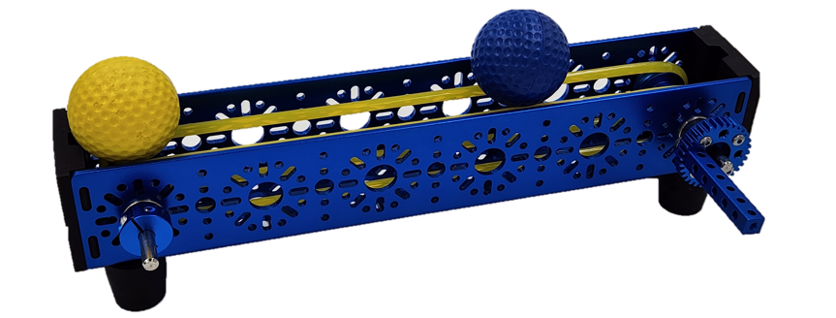

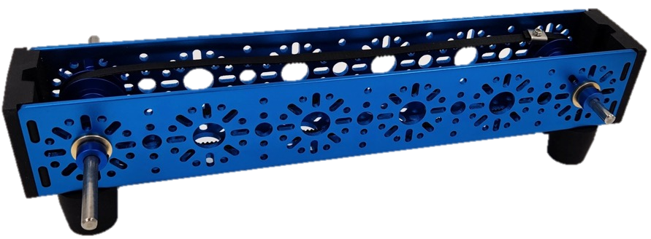

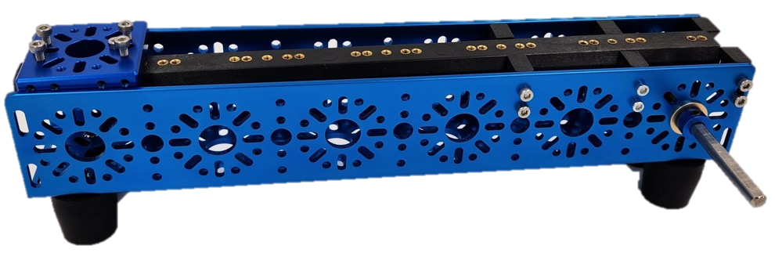

# Appendix D - Navigation and Localization

## D.1 – List of sample robots for Module D

|  |  |  |  |
| --- | --- | --- | --- |
| **Chassis** | **Picture** | **Chassis** | **Picture** |
| **1**  **Mecanum** |  | **4**  **Six Wheel Drive** |  |
| **2**  **Two Wheel Drive** |  | **5**  **The Stack** |  |
| **3**  **X-Drive** |  | **6**  **Unknown Variation** | **?** |

## D.2 – Example Task for Module D

One of the robots from D.1 could be chosen for use during module D. For the example task, below, let’s say the X-Drive robot was chosen.

Competitors must programme the X-Drive robot in Java or C++ with the provided project template. Competitors are not allowed access to the court except for the evaluated run. The robot must be calibrated and tested in their work area or one of the main module H courts. During an evaluation run the robot is placed in the start position and must end in the end position. No code modification is allowed once the robot enters the test area. The run is considered ended when the robot touches any part of the end position.

## A black rectangular object with white lines Description automatically generatedD.3 – Example Court for Module D

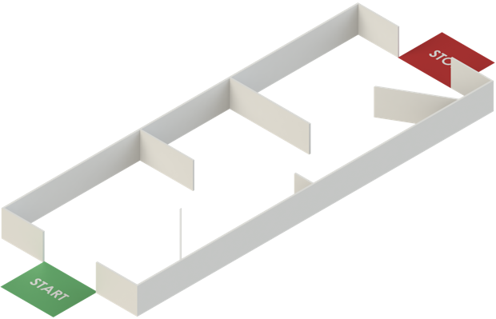

This design isn’t being used in WorldSkills Lyon 2024, when revealed on C1, Competitors will be able to see the actual field during the event.

# Appendix E –Vision

## E.1 – Example set fruits or Module E

This set will not be used in WorldSkills Lyon 2024. It should be used as sample objects for training purposes only.

|  |  |  |
| --- | --- | --- |
| **Peach** | **Apple** | **Lime** |
|  |  |  |
| **Garlic** | **Kiwi** | **Mangosteen** |
|  |  |  |
| **Chili Pepper** | **Banana** | **Orange** |
|  |  |  |
|  | **Pomegranate** |  |
|  |  |  |

## 

## E.2 - Example Task for Module E

Five random fruits will be chosen from the fruit in E.1. The Competitors must use vision to identify the fruit.

Competitors will be marked on a live stream video from the camera and vision programme. The Expert will place the fruit in the camera's FOV (Field of View), and the vision programme will either display the fruit’s identity on the camera feed or simply print a statement.

Fruit will only be placed one at a time in the camera FOV.

Sample results:

|  |  |  |
| --- | --- | --- |
| **Peach** | **Apple** | **Lime** |
| |  | | --- | |  | |  | |  | | --- | |  | |
| **Garlic** | **Kiwi** | **Mangosteen** |
| |  | | --- | |  | | |  | | --- | |  | |  |

# Appendix F - Robot Environment Interaction

## F.1 – Example Task for Module F

Competitors will be given an unknown object for the Competitor robot to manipulate. Despite being unknown, the object has similar characteristics in terms of scale and weight to the fruit in example E.1.

For the example task, Competitors will be given the Chilli Pepper from the Vision Module in E.1. Competitor robots are required to pick up the Chilli Pepper, drive 1m, turn around, drive back, and place the Chilli Pepper back in the same spot it was picked up from.

In this example, the height and placement of the Chilli-Pepper at the start is up to the Competitor.

Additional details will be provided during the Competition.

# Appendix G - Testing and Fault Finding

## G.1 – Example Task for Module G

A template is provided that shows how Module G is performed. Competitors will receive a robot or platform, that they will need to examine and complete the template as a checklist. The robot or platform will have some damaged or non-working parts that need to be identified.

# Appendix H - Performance Review and Commissioning

## H.1 – Task Procedures

In the morning breifing, Competitors will be provided a list of possible orders to be completed. Before starting a run , a dice roll will select which order to use. The Compeititors will input the order in which the robot must complete their tasks directly on their computers at the beginning of the performance run.

If a robot becomes stuck during a performance run, Competitors have two options to resolve the situation and resume the autonomous operation. Firstly, they may physically enter the court, relocate the robot to a predetermined position, and reactivate its autonomous mode.

Alternatively, Competitors can remotely control the robot to move it to a known location and then switch it back to autonomous mode. If remote control is employed, the run will be evaluated with a penalty, whereas if a Competitor enters the court, the penalty would be higher.

## H.2 – Example Field for Performance Review

There are three runs to be completed on the example court. Runs 1 and 2 are the same, but the order and layout of the grapes are different. Run 3 is completely different from runs 1 and 2.

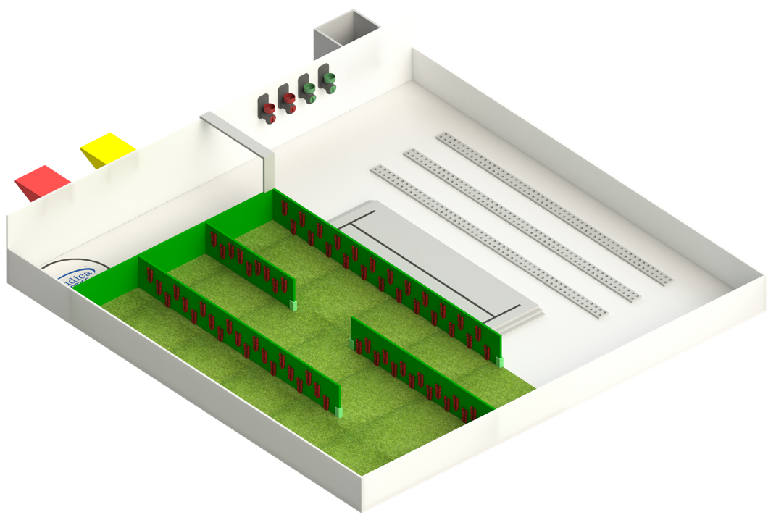

### H.2.1 Sample Sequence for Runs 1 and 2

1. Robot is placed on the court on the charging pad.
2. Competitor sends the order to the robot.
3. Grapes are placed on the grape vines according to the dice roll.
4. Competitor starts the robot by hitting the start button on the robot’s control panel.
5. Robot takes a basket from the red station.
6. Robot goes out and gets the first batch of the order.
7. Robot places the basket on the yellow/green station.
8. Robot repeats 5 – 7 until the order is complete
9. Robot goes back to the charging pad.
10. Robot flashes the red stopped LED on the control panel to indicate run complete. (Experts will not stop the time until this is displayed.)

Note: The Competitor's robot can complete the order using any strategy they wish. A robot can carry all three baskets at once if desired. However, the baskets must start on the red platform. When baskets are placed on the yellow/green station, Competitors may remove them and place them on the table or leave them.

### H.2.2 Sample Sequence for Runs 3

1. Robot is placed on the court, on the charging pad.
2. Competitor sends the order to the robot.
3. Seed Dispensers are randomized based on a roll of the dice.
4. Competitor starts the robot by hitting the start button on the control panel.
5. Robot travels to the seed dispensers and collects the seeds.
6. Robot plants the seeds based on the order.
7. Robot repeats 5-6 as needed.
8. Robot travels to the charging pad.
9. Robot flashes the red stopped LED on the control panel to indicate run complete. (Experts will not stop the time until this is displayed.)

### H.2.3 – Example Order Run 1

Order:

* First Batch
  + 5 x Red Grapes
* Second Batch
  + 2 x Yellow Grapes
* Third Batch
  + 2 x Green Grapes

Grape Placement on court (roll of dice selects placement)

* Vine 1: Red Grapes
  + Grapes on rows 1 and 3
* Vine 2: Green Grapes
  + Grapes on row 2
* Vine 3: Yellow Grapes
  + Grapes on rows 1 and 2

A complete order would have the following baskets on the yellow / green station:

* Basket with 5 x Red Grapes
* Basket with 2 x Yellow Grapes
* Basket with 2 x Green Grapes

The robot is on the charging station with a flashing stopped LED.

### H.2.4 – Example Order Run 2

Order:

* First Batch
  + 4 x Green Grapes
* Second Batch
  + 1 x Red Grapes, 1 x Green Grapes
* Third Batch
  + 2 x Yellow Grapes, 2 x Red Grapes

Grape Placement on the court (roll of dice selects placement)

* Vine 1: Green Grapes
  + Grapes on row 3
* Vine 2: Yellow Grapes
  + Grapes on rows 2 and 3
* Vine 3: Red Grapes
  + Grapes on row 1

A complete order would have the following baskets on the yellow/green station:

* Basket with 4 x Green Grapes
* Basket with 1 x Red Grapes and 1 x Green Grapes
* Basket with 2 x Yellow Grapes and 2 x Red Grapes

The robot is on the charging station with a flashing stopped LED.

### H.2.4 – Example Order Run 3

Order:

* Green Seeds
  + Planted in row 1 as a zigzag.
* Red Seeds
  + Planted in row 2 spaced evenly.

Dispenser Placement on the court (roll of dice selects placement)

* Green Dispensers
  + Dispensers 3 and 4
* Red Dispensers
  + Dispensers 1 and 2

A complete order would look like below:

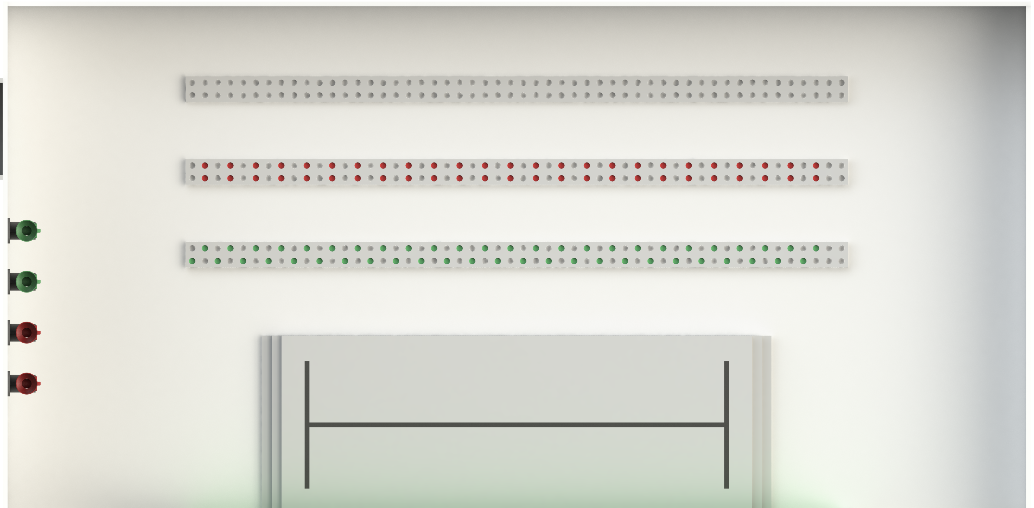

## H.3 –Module Items

This document contains objects that will be part of the final Test Project for WorldSkills Lyon 2024, and others that are just examples.

The Competitor Designed Basket will unchanged (depending on the Competitor’s preparation), and the Seed Pod Dispenser will have different colours (but the same action mechanism). The Grapes are only examples and will be replaced by a different object.

### H.3.1 – Competitor Designed Basket

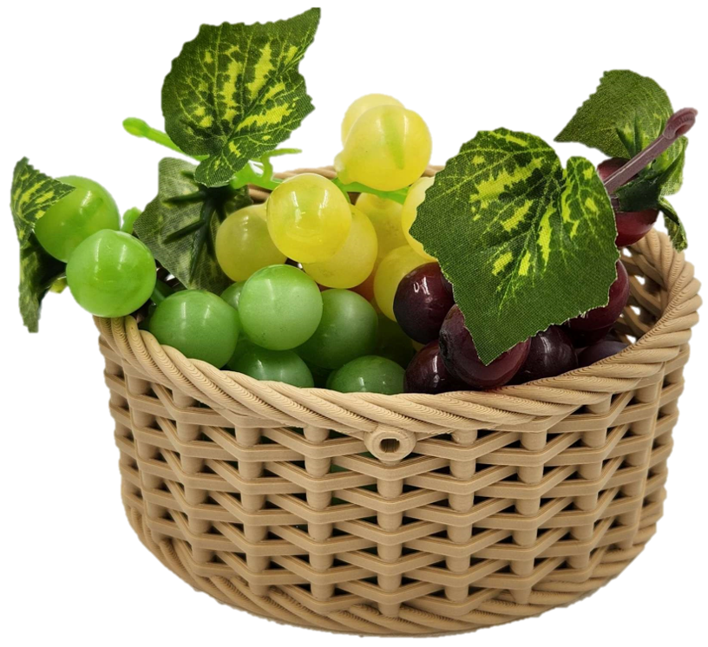

Competitors must design at least three baskets for their robots to deliver the test objects in. (The sample module uses grapes). The baskets can be made from anything but they must be manufactured by the Competitors.

Specs for the basket:

* No size restrictions
  + Maximum number of objects the basket should hold is 6.
* No weight restrictions (Does not count towards the robot’s manufactured parts weight limit).
* Three minimum baskets must be made. Spares are encouraged.
* The basket start location is the red station.
* Basket end location is defined on the run (e.g. the green or yellow station).

### H.3.2 – Seed Pod Dispenser

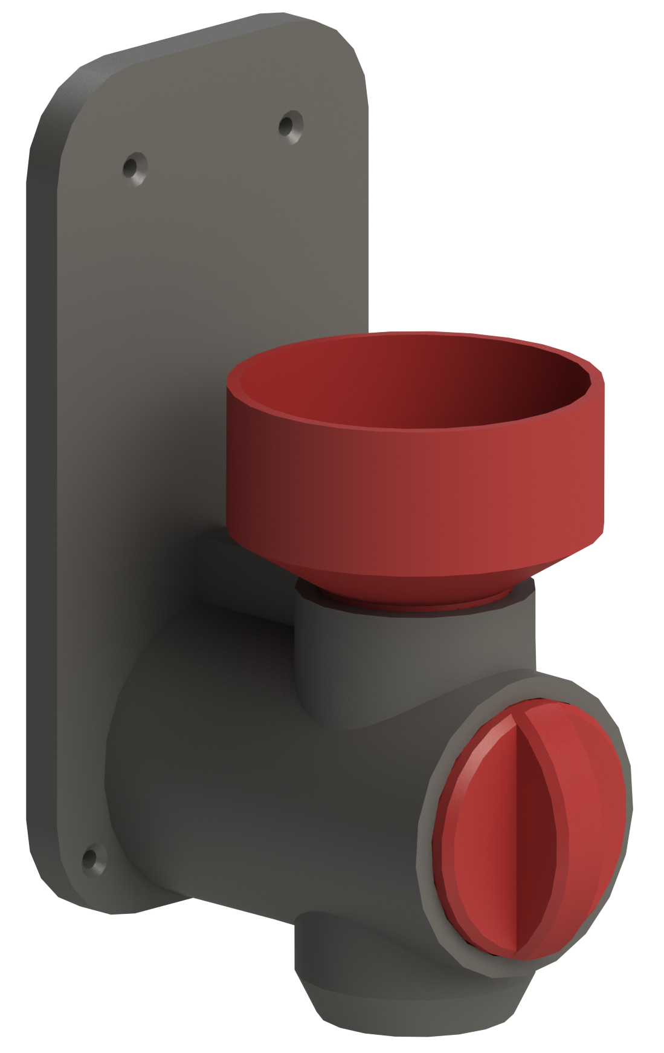

The seed dispenser is a 3D printed object attached to the court’s wall.

* Four dispensers per court
  + 2 x Red (sample)
  + 2 x Green (sample)
* Holds 25 seed pods.
* The robot must turn the dispenser handle to dispense the seeds into the robot.
  + If the robot can’t turn the dispenser the competitor may spin the handle (having a penalty).

At the competition the hopper and handle of the dispenser may have a different colour. In this training example Red and Green are used. The colour is chosen at the start of the run with a roll of the dice.

### H.3.3 – Sample Seed Pods



Specs:

* Size: 16 mm
* Colour: Red, Green
* Weight: ~5.44 g
* Normal 16 mm Marble

### H.3.4 – Sample Object: Grapes

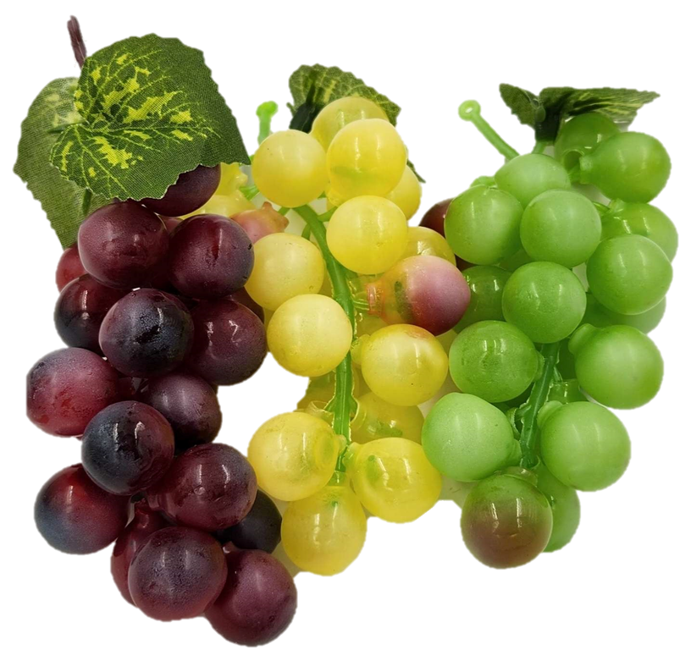

Specs:

* Measure: 12 cm – 14 cm
* # per stem: 20 – 23
* Weight: 24 g – 26 g
* Colour: Green, Red, Yellow